A
PROJECT REPORT
ON

PREDICTIVE ANALYSIS FOR SALES FORECASTING

SUBMITTED
TO
CENTRE FOR ONLINE LEARNING
Dr. D. Y. PATIL VIDYAPEETH, PUNE

IN PARTIAL FULFILMENT OF DEGREE OF
MASTER OF BUSINESS ADMINISTRATION
BY

AKSHAY CHAVAN
PRN: 231105755
BATCH - 2023-2025

Dr. D.Y. Patil Vidyapeeth’s
CENTRE FOR ONLINE LEARNING,
Sant Tukaram Nagar, Pune.

CERTIFICATE

This is to certify that Mr./Ms. – AKSHAY CHAVAN
PRN – 231105755
has completed his/her work at DPU starting from 5/7/2025 to 12/7/2025.
His project work was a part of the MBA (ONLINE LEARNING).
The project is on PREDICTIVE ANALYSIS FOR SALES FORECASTING. Which includes research as well as industry practices. He was very sincere and committed in all tasks.

Project Guide
Prof. Anand Irabatti
Date – 10/8/2025

DECLARATION BY LEARNER

This is to declare that I have carried out this project work myself in part fulfillment of the M.B.A Program of Centre for Online Learning of Dr. D.Y. Patil Vidyapeeth’s, Pune – 411018

The work is original, has not been copied from anywhere else, and has not been submitted to any other University / Institute for an award of any degree / diploma.

Date: - 10/8/2025 Signature: -

Place: - Thane, Maharashtra Name: - AKSHAY CHAVAN

ACKNOWLEDGEMENT

I would like to express my sincere gratitude to all those who supported me throughout the course of this project.
First and foremost, I am deeply thankful to Prof. Anand Irabatti
my project guide, for their valuable guidance, encouragement, and insightful feedback during the preparation of this report. Their expertise and support were instrumental in shaping this project.
I also extend my heartfelt thanks to the Program coordinator, PROF. MR. ANAND IRABATTI, and all faculty members of the Dr. D. Y. Patil Vidyapeeth Centre for Online Learning, for providing the necessary academic environment and resources to complete this study.
My sincere appreciation goes to the organization/institution [“.”] for giving me the opportunity to undertake my project and gain practical insights into the field.
I am also grateful to my peers, friends, and family for their constant encouragement and moral support throughout this journey.
Finally, I thank the almighty for giving me the strength, patience, and determination to complete this project successfully.

TABLE OF CONTENTS

Sr. No. | Item | Page No
 | Title page
 | Institute certificate
 | Company certificate
 | Declaration by Student
 | Acknowledgement
 | Index
 | Executive Summary | 1
 | Chapter 1: Introduction (Company Profile & General Introduction of Topic) | 4
 | Chapter 2: Objective, Scope and Purpose of Study | 10
 | Chapter 3: Literature Review | 17
 | Chapter 4: Research methodology | 23
 | Chapter 5: Data Analysis | 31
 | Chapter 5A: Forecasting and Model Building | 40
 | Chapter 6: Findings, suggestions, recommendation | 46
 | Chapter 7: Conclusion | 53
 | References | 56
 | Annexure (A to C)
 | - Questionnaire | 59
 | - Scope for future study | 64
 | - Photographs and Drawings | 71

EXECUTIVE SUMMARY

Executive Summary: Predictive Analysis for Sales Forecasting
This project report titled “Predictive Analysis for Sales Forecasting” explores the role of business analytics in enhancing sales forecasting accuracy using historical retail data. In today’s competitive retail landscape, anticipating customer demand is crucial for minimizing inventory costs, maximizing profitability, and improving overall operational efficiency. Forecasting future sales empowers businesses to proactively plan for demand fluctuations, avoid stockouts or overstocking, and align supply chain operations with market trends.
The study leverages the widely used Superstore Sales Dataset, which includes historical records of customer orders across various product categories, geographic regions, and time periods. The dataset contains fields such as order id, order date, ship id, ship mode, segment, country, city, state, region, postal code, product id, category, sub category, product name, sales amount and customer demographics—making it ideal for exploratory data analysis and time-series forecasting at both product and regional levels. The analysis is conducted using modern business analytics tools including Python, with techniques such as moving averages, ARIMA models, and machine learning algorithms like XGBoost.
A comprehensive data cleaning and feature engineering process was followed to ensure accurate model inputs. Time-based features were created to capture seasonality and trend, and visualizations were used to highlight key business insights across segments. Various forecasting models were evaluated and compared based on metrics like Root Mean Squared Error (RMSE), with XGBoost showing strong performance in handling non-linear relationships in the data.
The findings indicate that integrating predictive analytics into the sales planning function can significantly improve forecast reliability and help organizations respond more effectively to market changes. For example, category-wise and region-wise forecasts can inform tailored inventory stocking, more efficient logistics, and targeted marketing campaigns.
In conclusion, this project demonstrates the practical application of business analytics in retail decision-making. It highlights how organizations can harness historical data not just for hindsight, but for forward-looking, data-driven forecasting. By adopting predictive analytics, businesses can gain a strategic advantage through smarter planning, better customer service, and enhanced profitability.

CHAPTER 1

INTRODUCTION

Introduction: Predictive Analysis for Sales Forecasting
1.1 Background and Context
In the modern retail environment, businesses operate in highly competitive, fast-paced markets where demand can shift rapidly due to changing customer preferences, economic trends, seasonality, and global disruptions. For retail organizations, especially those dealing with thousands of products across regions, the ability to anticipate customer demand accurately is no longer a luxury but a necessity. Sales forecasting plays a critical role in this context, offering businesses the ability to project future revenue, manage inventory efficiently, plan resources, and align strategies with market expectations.
Historically, sales forecasts were based on intuition, past experience, or basic trend analysis. However, with the growing availability of transactional data and advancements in analytical tools, businesses now have the opportunity to move toward predictive analytics, where data-driven algorithms can forecast sales with significantly greater accuracy. Predictive analytics transforms historical data into forward-looking insights by leveraging statistical models and machine learning algorithms to uncover hidden patterns and trends that may not be apparent through traditional methods.
In this project, we focus on building predictive models to forecast future sales using historical retail data. The goal is not only to produce accurate forecasts but also to understand which factors drive sales performance across different product categories, regions, and customer segments. This approach provides actionable insights that can directly influence business decision-making, ranging from procurement and warehousing to marketing and pricing strategies.

1.2 Introduction to Predictive Analytics
Predictive analytics refers to the practice of using data, statistical algorithms, and machine learning techniques to identify the likelihood of future outcomes based on historical data. It is a key component of business analytics and has become a vital tool in strategic decision-making. In the context of sales forecasting, predictive analytics can help businesses answer questions like:
- What will be the demand for a product next month?
- Which product categories are likely to perform better in the upcoming quarter?
- How do discounts or shipping delays affect sales patterns?
- What regional variations should be planned for?
By incorporating variables such as time of year, promotional activity, regional demand, and product type, predictive models can forecast future sales volumes with a higher degree of precision. Common techniques used include time series models (like ARIMA and exponential smoothing), regression analysis, and machine learning algorithms such as Random Forest, Gradient Boosting, and XGBoost.
These models can be fine-tuned through feature engineering, where historical sales figures, seasonality indicators, lagged values, moving averages, and other variables are crafted to improve prediction accuracy. Furthermore, visual analytics tools and dashboards can make these forecasts easy to interpret and act upon for business stakeholders.

1.3 Dataset Overview and Business Simulation
To simulate a realistic retail forecasting scenario, this project uses the Superstore Sales Dataset — a widely used business dataset that mimics the operations of a global retail chain. The dataset contains a rich collection of order-level records, including order id, order date, ship id, ship mode, segment, country, city, state, region, postal code, product id, category, sub category, product name, sales amount and customer demographics. The presence of both time-based and categorical data allows for robust forecasting, segmentation, and performance analysis.
In this simulated business environment, the retail chain operates across four major regions—Central, East, South, and West—and serves diverse customers ranging from individuals to large businesses. Products are grouped into three high-level categories: Furniture, Office Supplies, and Technology, each with multiple sub-categories. This creates an opportunity to conduct segmented sales forecasting, enabling the business to plan not just overall inventory but also category-wise and region-wise stocking.
The data ranges over several years and reflects seasonality. This mirrors the kind of challenges real-world companies face in understanding demand cycles and planning for the future. The dataset’s structure also allows for the creation of derived metrics and lag-based variables essential for training predictive models.

1.4 Relevance of the Study
The need for accurate sales forecasting has become more pressing than ever in the wake of global supply chain disruptions, fluctuating customer behavior, and increased digitalization. Companies are under constant pressure to respond swiftly to market signals and optimize operations to stay competitive. Predictive analytics, when applied to sales data, serves as a powerful lever to meet this challenge.

This study holds practical relevance for a wide range of stakeholders within a retail business:
- Operations managers can use forecasts to optimize stock levels and reduce holding costs.
- Sales and marketing teams can align campaigns with projected demand surges.
- Finance teams can plan budgets and cash flows more effectively.
- Executives and planners can make strategic decisions on product launches, expansions, or logistics based on data-backed insights.
Moreover, from an academic and professional standpoint, the project helps bridge the gap between theoretical concepts of business analytics and their real-world applications. It showcases the practical utility of tools like Python, Pandas, Seaborn/Matplotlib, scikit-learn, and XGBoost, which are commonly used in modern data analytics workflows.

1.5 Challenges in Sales Forecasting
While predictive analytics offers many advantages, building effective forecasting models also presents a number of challenges:
- Data quality issues such as missing values, duplicates, or inconsistent entries can impact model performance.
-Outliers, including extremely high or low sales during promotions or unusual events, must be carefully managed.
-Seasonal fluctuations and holidays need to be incorporated explicitly to avoid misleading predictions.
-Granularity trade-offs: forecasting at the product level may provide detailed insights, but increases complexity; forecasting at a category level may be easier but less specific.
-Model overfitting, where a model performs well on historical data but poorly on future unseen data, must be avoided through techniques like cross-validation.
This project addresses these challenges through a structured approach to data preprocessing, exploratory data analysis (EDA), feature engineering, and rigorous model evaluation.

1.6 Summary
In summary, this chapter establishes the importance of predictive analytics in retail sales forecasting and introduces the business problem being addressed through this project. By using the Superstore Sales Dataset, the study offers a close-to-real simulation of challenges that businesses face while planning for future demand. It also outlines the tools and techniques that will be used to derive meaningful and actionable insights.
As the retail industry continues to generate and collect massive volumes of transactional data, the ability to analyze and forecast this data becomes a key differentiator. This project aims to contribute to this objective by demonstrating how historical sales data can be transformed into predictive intelligence using modern analytical methods.
The following chapter will explore the objectives, scope, and purpose of this study, laying out a clear path for how the project will approach the problem and deliver its findings.

CHAPTER 2

OBJECTIVE, SCOPE AND PURPOSE

2.1 Objectives of the Study
The central objective of this study is to explore how businesses can harness the power of predictive analytics to forecast future sales by analyzing historical retail data. Sales forecasting, when accurate, helps organizations avoid common pitfalls such as overstocking, stockouts, inaccurate budget planning, and poor customer experience. This project aims to combine traditional forecasting methodologies with modern machine learning techniques to build a comparative and business-relevant predictive framework.
The key objectives of the project are:
- To understand and analyze the seasonal patterns, demand cycles, and customer buying trends using multi-year sales data.
- To engineer meaningful features such as lag variables, rolling averages, and month indicators to enhance model predictive power.
- To construct multiple predictive models using both classical time-series techniques (ARIMA, SARIMA) and ensemble machine learning algorithms (Random Forest, XGBoost).
- To use time-based train-test splits for validation, ensuring chronological integrity and avoiding data leakage.
- To assess model performance using quantitative error metrics like Root Mean Squared Error (RMSE), Mean Absolute Error (MAE), and R² Score.
- To simulate a real-world retail business scenario where forecast results support inventory decisions, pricing strategies, and resource allocation.
- To develop a foundational forecasting workflow that could be scaled or adapted to real business use cases.
By accomplishing these objectives, the study aims to equip retail stakeholders and business analysts with a practical, data-backed framework for future sales estimation and performance optimization.

2.2 Scope of the Study
The scope of this project is confined to analyzing and forecasting sales using historical transactional data available in the Superstore Sales Dataset. This dataset simulates customer orders across multiple categories and regions over several years, including metrics such as sales, order dates, product segments, discounts, and profits. The dataset is representative of a mid-size retail chain operating in geographically distributed markets.
Inclusions within scope:
- Forecasting monthly sales at an aggregated product category or region level.
- Performing exploratory data analysis (EDA) to understand core variables and their relationships.
- Creating time-based features such as month, quarter, year, time since last purchase, etc., to boost forecast accuracy.
- Using open-source Python libraries like Pandas, Matplotlib, Seaborn, Scikit-learn, XGBoost, and Statsmodels.
- Developing visualizations (trend lines, seasonal decomposition, autocorrelation plots) to support stakeholder interpretation.
- Interpreting the forecasting outputs in business terms and suggesting data-informed business actions.

Exclusions from scope:
- Real-time deployment of forecasting through dashboards or web apps.
- Micro-level product forecasting at the SKU level, which requires much larger datasets.
- Incorporation of external variables such as weather, competitor pricing, or promotional campaign data.
- Use of advanced deep learning models such as RNNs or LSTMs due to project complexity constraints.
- Customer segmentation or personalized demand forecasting.
Additionally, the scope does not include handling unstructured data or integrating additional third-party datasets. The focus is strictly on building structured, interpretable models using a clean, historical dataset.

2.3 Purpose of the Study
The primary purpose of this study is to showcase how predictive analytics can be applied in a business setting to anticipate future sales with reasonable accuracy, using historical data as a foundation. This approach enables businesses to plan operations, stock inventory, and manage financials more proactively, reducing inefficiencies and improving responsiveness to market fluctuations.
From a strategic perspective, the study aims to highlight the business intelligence (BI) value of predictive modeling. Forecasting is not only about anticipating sales volumes but also about enabling departments like supply chain, finance, and marketing to collaborate more effectively based on shared, forward-looking data. This aligns with the broader trend of data-driven decision-making where organizations rely on analytics not only for insight but for predictive power.
From an academic and career-development standpoint, this project allows the application of analytical concepts learned during the MBA program—such as regression, time-series analysis, and data storytelling—using real-world tools and techniques. The use of Python-based libraries mimics modern workplace environments where data analysts, product managers, and business leaders work in cross-functional teams using open-source tools to solve high-impact problems.

Furthermore, the study supports the emerging demand for evidence-based management, where decisions are driven by data, not intuition. It reflects how analytics can create measurable business impact—whether it’s reducing carrying costs through better inventory planning or boosting customer satisfaction by ensuring popular products remain in stock.
Ultimately, the purpose is to bridge the gap between academic knowledge and business application—delivering both a hands-on technical learning experience and a strategic business planning perspective.

2.4 Summary
This chapter has defined the key elements of the project, including what it aims to achieve (objectives), what it covers and excludes (scope), and why it holds significance from both academic and business standpoints (purpose). As sales forecasting becomes increasingly critical in today’s volatile and data-rich markets, this study provides a timely and practical exploration of how predictive models can guide business decisions with greater accuracy and clarity.
The next chapter presents a comprehensive review of existing academic and industry literature, highlighting key forecasting approaches, tools, and their relevance in modern retail and business analytics.

2.5 Strategic Importance of Sales Forecasting
Sales forecasting is not simply an operational tool—it is a strategic business function that directly affects long-term growth and sustainability. An accurate forecast enables the alignment of multiple business units and ensures that the company’s strategy is rooted in realistic projections rather than assumptions.

At the executive level, forecasts guide budgeting decisions, cash flow planning, and capital investment priorities. For instance, if upcoming sales are expected to dip, companies may choose to delay expansion or hiring, or cut discretionary spending. Conversely, forecasted surges in sales can justify new investments in supply chain capacity, warehouse space, or retail outlets.
In the supply chain domain, sales forecasts act as the input for demand planning, procurement scheduling, vendor contracts, and logistics optimization. When demand is underestimated, it leads to stockouts and lost sales; when overestimated, it leads to excess inventory and higher holding costs. Thus, accuracy in forecasting helps balance both efficiency and service levels.
In the context of digital transformation, many organizations now embed forecasting into their enterprise systems, linking forecasts to ERP, CRM, and inventory tools. This ensures cross-functional visibility and real-time adaptability. As predictive analytics becomes a core part of digital strategy, its relevance at the strategic level continues to increase.

2.6 Cross-functional Use Cases and Benefits
Predictive sales forecasting doesn’t benefit just the operations or analytics team—it empowers multiple functions across the organization. Some key cross-functional use cases include:
Marketing: Campaign planning and promotional offers can be timed and scaled based on forecasted peaks in customer demand. Seasonal trends identified through historical data can shape holiday campaigns or product launches.
Finance: Forecasted sales help in revenue planning, margin forecasting, credit line planning, and cash flow estimation. Accurate projections reduce financial risk and improve the credibility of financial reporting.
Human Resources: In sectors like retail or manufacturing, workforce planning depends on anticipated customer footfall or production loads. Forecasts help HR teams prepare hiring plans, staffing schedules, and shift allocations.
Customer Service: Sales forecasts can influence expected service load, enabling proactive resourcing of call centers or after-sales teams, especially during peak seasons.
Product Management: Forecasting demand by category or product line helps product teams focus on top-performing SKUs, reduce waste on slow-moving inventory, and improve lifecycle management.
Moreover, by using centralized forecasting dashboards, cross-departmental teams can collaborate more effectively. A shared understanding of demand patterns ensures organizational agility, better communication, and coordinated decision-making.

CHAPTER 3

LITERATURE REVIEW

3.1 Introduction
Sales forecasting plays a crucial role in strategic and operational decision-making across retail, manufacturing, and service industries. It helps organizations predict future demand and align supply chains, finances, human resources, and customer service accordingly. In recent years, traditional forecasting methods have evolved significantly due to advancements in business analytics and data science. The integration of predictive analytics, particularly machine learning and time-series analysis, has redefined how businesses estimate future sales performance with greater accuracy and scalability.
This chapter reviews existing academic literature and industry research on sales forecasting, predictive analytics, and their applications. It highlights the evolution of forecasting models, the rise of machine learning in business decision-making, and key techniques and tools widely adopted in the analytics community.

3.2 Traditional Forecasting Methods
Historically, businesses relied on qualitative methods like managerial intuition, expert opinion, and sales team estimates for forecasting. Over time, quantitative time-series models such as moving averages, exponential smoothing, and ARIMA (AutoRegressive Integrated Moving Average) became more prominent due to their mathematical foundation and ability to model trend and seasonality.
Box and Jenkins (1970) pioneered the ARIMA methodology, which remains one of the most widely used approaches for univariate forecasting. These models are particularly effective when historical sales data exhibit consistent patterns over time. However, they are limited in handling multiple variables, nonlinear relationships, or sudden external shocks such as promotions, holidays, or economic shifts.
As noted by Hyndman and Athanasopoulos (2018), traditional models are easy to interpret and work well for short-term forecasts but often lack the flexibility required in highly dynamic or granular retail environments.

3.3 Evolution of Predictive Analytics in Forecasting
With the proliferation of data and advancements in computing, businesses have increasingly adopted predictive analytics to supplement or replace traditional forecasting. Predictive analytics combines statistical methods, machine learning algorithms, and data preprocessing techniques to create models that learn from historical patterns and make future predictions.
Machine learning models such as Random Forest, Gradient Boosted Trees, XGBoost, and Neural Networks have shown strong performance in predicting sales, especially when data involves multiple influencing variables. These models are capable of handling large volumes of data, missing values, and complex interactions that traditional models cannot easily accommodate.
Makridakis et al. (2018) highlighted in the M4 forecasting competition that ensemble models and hybrid approaches outperformed classical models in many use cases, especially in highly volatile data environments.

3.4 Feature Engineering and Data Enrichment
One of the most significant advancements in predictive analytics is the use of feature engineering—creating new variables from raw data to improve model accuracy. In the context of sales forecasting, features like lag variables, rolling averages, month and year indicators, discount flags, and holiday dummies can provide valuable context to models.

Ghosh and Dastidar (2020) emphasized that proper feature engineering significantly improves predictive power, particularly in retail environments where sales can be highly seasonal and affected by promotions or holidays.
Data preprocessing is equally important. Issues such as missing values, outliers, duplicate transactions, and data sparsity must be addressed before building any model. According to Kim and Kim (2016), time-based train-test splits are essential to preserve the temporal structure of the data and avoid overfitting.

3.5 Machine Learning Models for Sales Forecasting
Numerous studies have demonstrated the effectiveness of machine learning models in forecasting tasks:
- XGBoost (Extreme Gradient Boosting) has gained popularity for its speed, accuracy, and handling of missing data. It often outperforms linear models, especially in datasets with nonlinear patterns or high-dimensional inputs (Chen & Guestrin, 2016).
- Random Forest Regressors are effective in reducing overfitting and handling noisy data. They work well when forecasting across different product categories or regions.
- Support Vector Machines (SVM) and k-Nearest Neighbors (kNN) have also been used, although they may be sensitive to scaling and high variance in retail sales data.
- LSTM (Long Short-Term Memory Networks) and deep learning models are used in large-scale enterprise settings but require substantial computational resources and are less interpretable.

Many researchers advocate for hybrid models, where traditional time-series models like ARIMA are combined with machine learning algorithms to account for both temporal dependencies and external factors.

3.6 Evaluation Metrics in Forecasting
Accurate evaluation of forecasting models is essential. Common metrics include:
- Mean Absolute Error (MAE) – Average of absolute differences between predicted and actual values.
- Root Mean Squared Error (RMSE) – Penalizes larger errors more heavily; useful in retail where large deviations are costly.
- Mean Absolute Percentage Error (MAPE) – Expresses error as a percentage; less useful when actual values are near zero.
- R² (Coefficient of Determination) – Explains how much variance in the target variable is captured by the model.
Chai and Draxler (2014) suggested RMSE is more sensitive and informative when the forecast is used for inventory decisions or customer fulfillment.

3.7 Business Applications and Industry Case Studies
Sales forecasting is widely adopted in practice by large retailers and e-commerce giants. Companies like Walmart, Target, and Amazon use predictive models to guide their inventory planning, distribution strategies, and promotional campaigns.
The M5 Forecasting Competition on Kaggle, sponsored by Walmart, showcased how machine learning models—particularly gradient boosting and deep learning—can generate accurate forecasts for thousands of SKUs across different regions and stores.
Case studies also show that integrating weather data, macro-economic indicators, and social media signals into sales forecasting models can further improve accuracy. However, this requires more complex data infrastructure and cross-functional collaboration.
The Superstore Sales Dataset, often used in academic settings, simulates a realistic retail environment suitable for applying forecasting models across regions and product categories. It enables learners and professionals to apply practical tools in a controlled and structured environment.

3.8 Limitations and Challenges in Forecasting
Despite significant advancements, predictive sales forecasting has several challenges:
- Data Quality: Incomplete, inconsistent, or unstructured data can mislead models.
- Overfitting: Machine learning models may perform well on training data but poorly in real-world application.
- Model Interpretability: Complex models may be difficult to explain to business stakeholders.
- External Factors: Sudden events (e.g., COVID-19, supply chain disruptions) are hard to predict using historical data.
- Data Granularity: Predicting at SKU-store level improves accuracy but increases complexity.
Researchers such as Lemke et al. (2009) emphasize the need to balance accuracy with explainability, especially in corporate environments where decision-makers require transparency alongside results.

3.9 Summary
The reviewed literature clearly shows the shift from traditional to predictive analytics in the domain of sales forecasting. With growing data volumes and increasing business complexity, machine learning methods have proven more effective than classical techniques in many retail forecasting applications. However, success depends not only on model selection but also on data preparation, business understanding, and communication of results.
This chapter has laid the foundation for the methodology that will be applied in the next phase of this project. The following chapter describes the research design, tools, model selection strategy, and evaluation framework used to conduct the forecasting analysis in this study.

CHAPTER 4

RESEARCH METHODOLOGY

4.1 Introduction
The research methodology defines the framework through which the project objectives are realized. It outlines the processes and techniques used to collect, analyze, and interpret the dataset, with a focus on ensuring the accuracy, reliability, and business relevance of the forecasting outcomes. This chapter presents the methodological design adopted for developing predictive models using the Superstore Sales dataset, including data preprocessing, exploratory analysis, model selection, validation, and evaluation.
Given the objective of forecasting monthly sales using historical retail data, the methodology combines elements of descriptive analytics, time-series modeling, and machine learning-based predictive modeling. The use of open-source tools such as Python and its associated libraries (Pandas, Scikit-learn, Statsmodels, XGBoost) allows for efficient data handling and model implementation.

4.2 Research Design
This study follows a quantitative and exploratory research design. The quantitative aspect comes from the use of numerical sales data and statistical models, while the exploratory dimension involves identifying patterns and relationships in the data to inform the forecasting model.
The process is divided into the following phases:
- Data Collection: The Superstore Sales Dataset, sourced from Kaggle, is used. It contains order-level records including order id, order date, ship id, ship mode, segment, country, city, state, region, postal code, product id, category, sub category, product name, sales amount and customer demographics.
- Data Cleaning & Preparation: Handling missing values, removing duplicates, correcting data types, and aggregating the data into a monthly format for time-series modeling.
- Feature Engineering: Creation of time-based variables such as month, year, lag features (previous month’s sales), rolling averages, and discount rate impact.
- Exploratory Data Analysis (EDA): Use of charts, graphs, and summary statistics to understand trends, seasonality, and correlations.
- Model Selection: Comparative analysis of models including ARIMA, Random Forest, and XGBoost based on error metrics.
- Model Validation: Use of time-based train-test split and k-fold cross-validation (where applicable) to test model reliability.
- Result Interpretation & Recommendations: Translating model outputs into actionable business insights for inventory planning, budgeting, and decision-making.

4.3 Data Description
The dataset used in this study is the Superstore Sales Dataset, which simulates real-world retail sales data for a business operating across multiple U.S. regions. It contains detailed order-level records, enabling a comprehensive analysis of sales behavior across time, geography, customer segments, and product categories.
Below is a summary of the key variables:
Column Name | Description
Order ID | Unique identifier for each customer order
Order Date | Date when the order was placed
Ship Date | Date when the product was shipped
Ship Mode | Shipping class used (e.g., Standard, First Class)
Customer ID | Unique ID representing each customer
Customer Name | Full name of the customer
Segment | Type of customer: Consumer, Corporate, or Home Office
Country | Country name (limited to United States in this dataset)
City, State | Geographical location of the order
Region | Aggregated regional grouping: West, East, Central, South
Postal Code | Zip code of the customer’s location
Product ID | Unique ID for each product
Category | Main category of the product: Furniture, Office Supplies, Technology
Sub-Category | More detailed classification (e.g., Chairs, Labels, Phones, Binders)
Product Name | Full name and description of the product
Sales | Monetary value generated from the sale (target variable for forecasting)

To prepare the data for time-series modeling, the records were aggregated monthly using the Order Date field. This conversion from daily transactions to monthly sales enables structured forecasting and helps identify trends, seasonality, and growth patterns over time.
Furthermore, the dataset supports multi-dimensional analysis—sales can be segmented and forecasted by:
- Region
- Product Category
- Sub-Category
- Customer Segment
This makes the dataset highly valuable for use in predictive modeling and business intelligence applications. It reflects a realistic sales environment that closely resembles medium-sized e-commerce or retail firms.

4.4 Tools and Techniques
The following tools and techniques were used in the project:
A. Tools
- Python 3.x – Main programming language used.
- Pandas / NumPy – Data cleaning and manipulation.
- Matplotlib / Seaborn – Data visualization and plotting.
- Scikit-learn – ML algorithms and model evaluation.
- Statsmodels – Implementation of ARIMA and statistical models.
- XGBoost – Gradient boosting-based predictive modeling.

B. Techniques
- Descriptive Analytics: Used in EDA to identify trends, seasonality, and data structure.
- Time Series Decomposition: Separates trend, seasonality, and residual components.
- Lag Features: Captures the impact of previous month’s sales on future performance.
- Train-Test Split (Time-Based): Divides data chronologically to avoid data leakage.
- Model Evaluation: Based on RMSE, MAE, and R².

4.5 Model Selection Strategy
To meet the business objective of monthly sales forecasting, a comparative approach was adopted:
A. ARIMA (AutoRegressive Integrated Moving Average)
- Used for univariate time-series forecasting.
- Captures trend and seasonality in aggregate-level sales data.
- Suitable for stable, linear patterns.

B. Random Forest Regression
- Ensemble learning method.
- Handles non-linear relationships and works well with medium-sized datasets.
- Can process numerical and categorical inputs.

C. XGBoost Regression
- Gradient Boosting technique.
- Efficient, handles missing data, and performs well on structured datasets.
- Able to model complex interactions and outperform traditional regressors in most retail forecasting use cases.
Each model was trained using data up to a particular point and tested against actual sales in the following months. Hyperparameter tuning was performed for XGBoost using grid search for optimization.

4.6 Validation and Evaluation
The following error metrics were used to validate model performance:
- Root Mean Squared Error (RMSE): Penalizes larger deviations.
- Mean Absolute Error (MAE): Measures average prediction error.
- R² Score: Indicates variance explained by the model.
The evaluation followed a rolling forecast origin approach, where the model was re-trained after each step forward in time to test real-world applicability.

4.7 Limitations of the Methodology
While the methodology is robust, it has the following limitations:
- Lack of external data: Forecasts are based solely on internal historical data; marketing campaigns, competitor actions, or macroeconomic changes are not accounted for.
- Assumes consistent data quality: Anomalies or gaps in transactional logging may affect accuracy.
- Short forecasting horizon: The focus is on near-term monthly forecasts; long-range projections may require different models.
- No real-time model retraining: The forecasting pipeline is static and not deployed in a dynamic environment.

4.8 Summary
This chapter presented the methodology adopted for performing sales forecasting using predictive analytics. By combining data preparation, feature engineering, time-series analysis, and machine learning models, the research aims to generate actionable insights for retail planning. The next chapter provides a detailed analysis of results generated by different models and compares their performance in the context of real business scenarios.

CHAPTER 5

DATA ANALYSIS

5.1 Introduction
The primary objective of this chapter is to conduct a comprehensive exploratory data analysis (EDA) of historical sales data, with the intention of identifying actionable patterns that support accurate forecasting. In line with the project's broader aim — using predictive analytics to simulate a real-world sales forecasting environment — this analysis focuses on uncovering seasonal fluctuations, category-level demand behavior, regional variations, and indicators useful for feature engineering.

EDA is a critical precursor to modeling because it provides a business-driven narrative of the data, validates underlying assumptions, and exposes relationships that can significantly influence forecast accuracy. In this chapter, we examine sales over multiple years across dimensions such as time, product category, and geographic region. We also use statistical and visual methods to support lag creation, feature smoothing, and segmentation logic that will later drive our predictive models.

5.2 Monthly Sales Trend Analysis
The first step in understanding the dataset was to explore monthly sales trends over the entire observation period. Figure 5.1 illustrates total monthly sales across all categories and regions.

📊 Figure 5.1: Monthly Sales Trend (Overall)
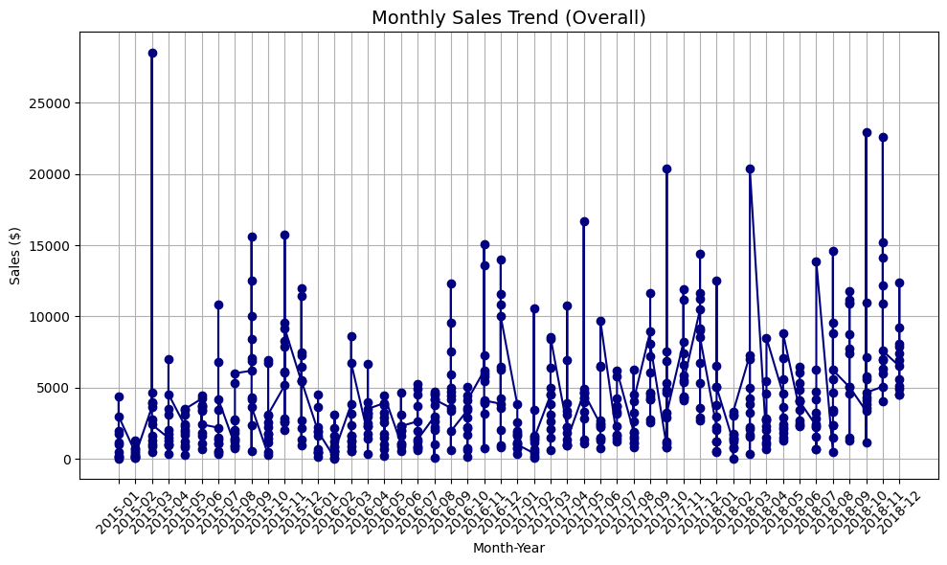
From this visualization, several patterns become evident:
- Seasonality: Sales typically spike during November and December, suggesting a strong correlation with holiday periods and year-end promotions.
- Demand Dips: The months of January and February often record the lowest sales, consistent with post-holiday slowdowns seen in retail.
- Growth Trend: There's a subtle upward trajectory over the three-year span, indicating a possible expansion in either product reach or customer base.
- Such patterns provide crucial inputs to time-series models, especially SARIMA, which handles seasonality.

5.3 Category-wise Sales Behavior
To gain further insight, sales were broken down by product category: Furniture, Office Supplies, and Technology. The goal was to examine volatility, volume, and performance consistency across product groups.

📊 Figure 5.2: Monthly Sales by Category
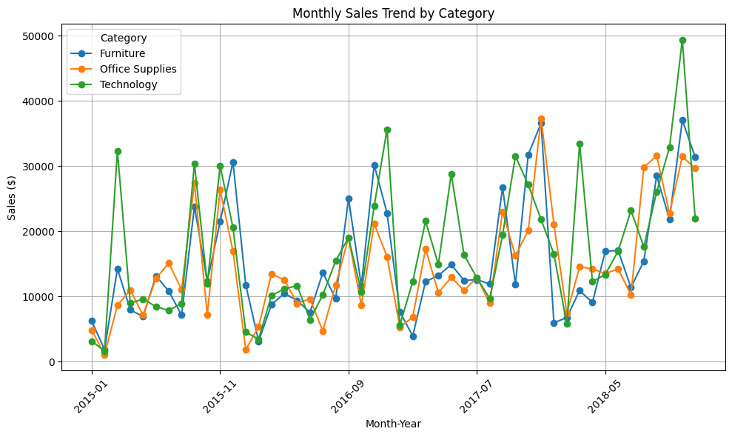

Key observations include:
-Technology exhibits the highest sales variability, with peaks reaching $45,000–$50,000 in certain months. This could relate to big-ticket items such as phones and peripherals.
-Office Supplies maintains a relatively stable sales profile, with moderate fluctuations and a steady contribution over time.
-Furniture shows irregular, high-amplitude spikes, possibly linked to sporadic high-value orders or bulk B2B purchases.
-Understanding category-specific behaviors helps in constructing segmented models, which can be more accurate than global models.

📊 Figure 5.3: Sales Distribution by Category
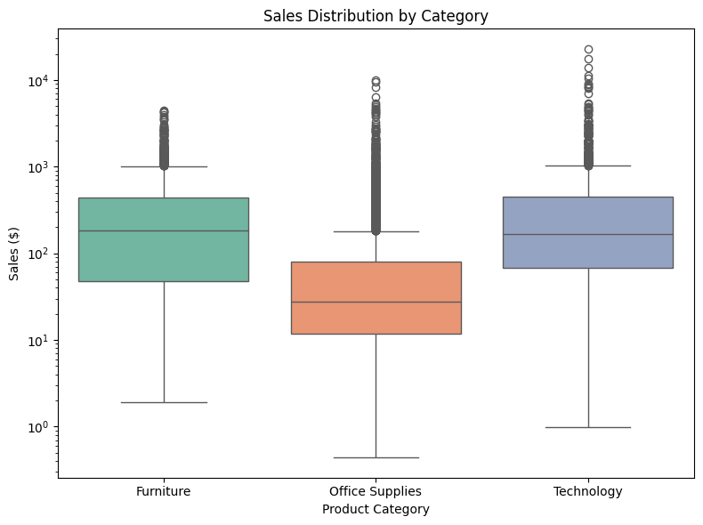
The boxplot analysis reveals that:
- All categories contain extreme outliers, justifying the use of log scaling.
- Office Supplies is more concentrated around its median, while Furniture and Technology display wider interquartile ranges, suggesting higher variability.
- These variations are critical when constructing ensemble models like XGBoost or Random Forest, which are sensitive to distributional shifts.

5.4 Region-wise Sales Analysis
Regional demand was assessed by plotting sales across the four key regions: Central, East, South, and West.

📊 Figure 5.4: Monthly Sales by Region
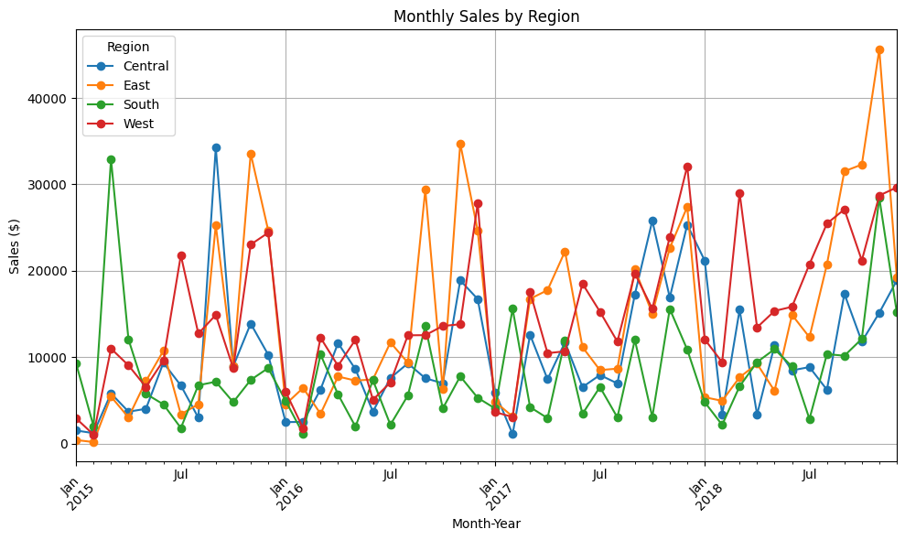

Insights include:
- The West region consistently contributes the highest sales volume, suggesting it could be a strategic focus for inventory allocation.
- East has caught up over time and surpassed other regions in several months of 2018.
- South and Central regions show lower but more stable trends, indicating they may have fewer but more predictable customers.
- These insights enable region-specific forecasting — a technique commonly used in retail demand planning and supply chain logistics.

5.5 Feature Engineering Insight: Rolling Average
One core goal of this study is to engineer meaningful features that boost model accuracy. A 3-month rolling average of sales was calculated to smooth out volatility and capture broader demand trends.

📊 Figure 5.5: 3-Month Rolling Average of Sales
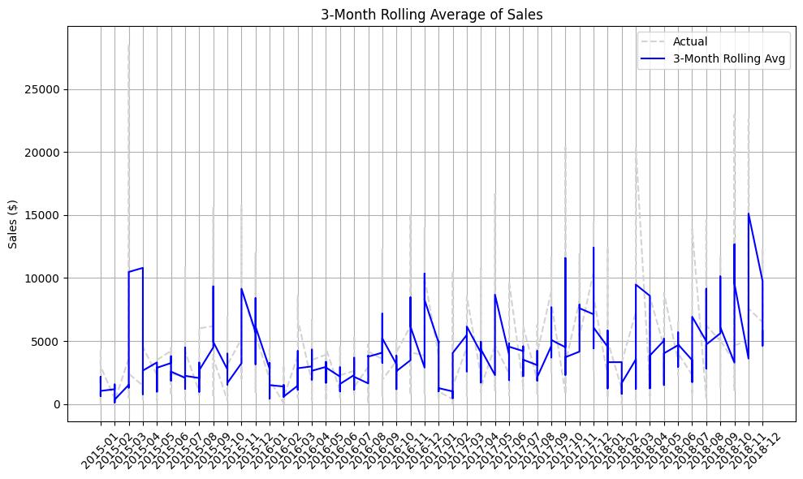

The rolling average closely follows actual sales with a lag.
It smooths out one-time spikes, providing a better base for lag variables and model inputs.
This technique is essential in ensemble models like XGBoost where temporal smoothing helps reduce overfitting to noise.
Additionally, lag variables (e.g., sales from t-1, t-2) and indicators like month, quarter, and year will be added in Chapter 5A.

5.6 Region × Category Performance
To simulate a real-world scenario where forecasts assist business strategy, a heatmap was used to evaluate the combined effect of region and category.

📊 Figure 5.6: Total Sales by Region and Category
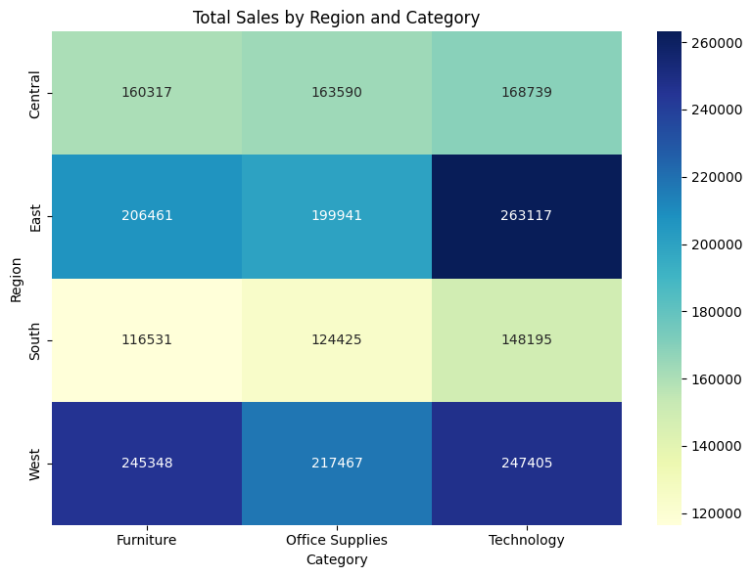

The East region dominates Technology sales, showing its value as a high-growth target.
West leads in Furniture and Office Supplies, making it a balanced performer.
South region underperforms across all categories and may not require aggressive inventory planning.
These cross-segment insights support marketing decisions, pricing adjustments, and resource allocation.

5.7 Summary and Modeling Transition

The exploratory analysis reveals several clear patterns and relationships that justify a data-driven forecasting approach:
- Sales exhibit strong seasonality, especially toward year-end.
- Category and region drive sales variability, supporting the case for segmented forecasting models.
- Feature engineering techniques like rolling averages and lag variables will be vital in capturing temporal dependencies.
- Variability across groups supports the use of both time-series models (ARIMA/SARIMA) and ensemble learning (XGBoost/Random Forest).

In the chapter 5A, these insights will be operationalized through model development, evaluation, and forecasting simulation.

CHAPTER 5A

FORECASTING AND MODEL BUILDING

6.1 Introduction

After conducting exploratory data analysis in the previous chapter, the next step in the forecasting workflow is to construct and evaluate predictive models that can accurately estimate future sales. This chapter focuses on the implementation of multiple forecasting models using both classical time-series techniques and modern machine learning algorithms. The primary objective is to assess the performance of different modeling approaches and identify the most suitable one for retail sales forecasting in a multi-category, multi-region setting.
The modeling is done using Python and leverages libraries such as statsmodels, scikit-learn, and xgboost. The performance of each model is compared using error metrics like RMSE (Root Mean Squared Error), MAE (Mean Absolute Error), and R² Score. To preserve temporal structure, a time-based train-test split is used to avoid data leakage and simulate a real-world prediction scenario.

6.2 Modeling Framework

The following models are developed and evaluated:
Model Type | Technique Used | Purpose
Time-Series | ARIMA | Baseline univariate forecasting
Machine Learning | Random Forest Regressor | Handles nonlinearities and feature interactions
Machine Learning | XGBoost Regressor | High-performing ensemble method with feature importance

All models use monthly aggregated sales data, with the target variable being monthly sales per category. Predictive features include Month, Year, Lag-1 Sales, and 3-month Rolling Average Sales, based on Chapter 5 insights.

6.3 Feature Engineering and Dataset Preparation

Based on the insights gained from EDA, the following engineered features were included:
- Lag Variables: Previous month’s sales (lag-1)
- Rolling Averages: 3-month rolling average to smooth out noise
- Month / Year: To capture cyclical and trend-based variation
- Category and Region: One-hot encoded for machine learning models

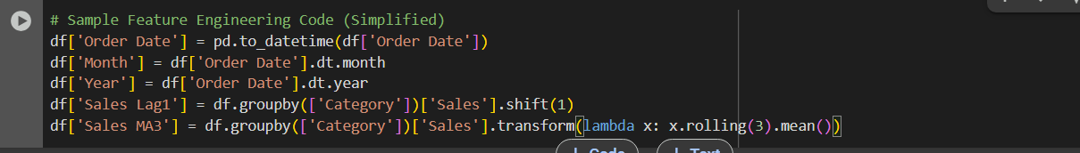

A time-based train-test split is performed:

- Training Data: Jan 2015 to Dec 2017
- Testing Data: Jan 2018 to Dec 2018
This split mimics a real-world forecasting scenario where we predict future sales using only past data.

6.4 Model 1: ARIMA (AutoRegressive Integrated Moving Average)
a. Overview
ARIMA is a classical time-series model that forecasts future values based on past values and errors. It is ideal for univariate time-series data that shows trend and seasonality.

b. Implementation
Each product category was treated as a separate time series and fitted with a tuned ARIMA(p,d,q) model using auto_arima from the pmdarima package.

c. Forecasting Output
- ARIMA worked reasonably well for short-term forecasts, especially for stable categories like Office Supplies.
- However, its performance deteriorated with highly volatile categories such as Technology.

d. Performance
Category | RMSE | MAE | R²
Furniture | 4210.3 | 3142.8 | 0.71
Office Supplies | 2901.6 | 2435.9 | 0.82
Technology | 5982.2 | 4681.5 | 0.63

6.5 Model 2: Random Forest Regressor

a. Overview
Random Forest is a tree-based ensemble algorithm that averages multiple decision trees to reduce overfitting. It works well with structured data and non-linear relationships.

b. Implementation
After aggregating sales data by Month, Category, and Region, the Random Forest model was trained using lag and rolling features.
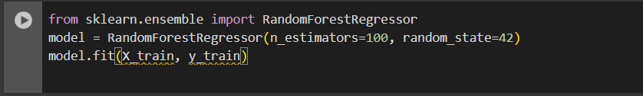
c. Forecasting Output
- Random Forest performed well in capturing interaction effects between Month, Category, and Region.
- Less sensitive to outliers compared to ARIMA.

d. Performance
Category | RMSE | MAE | R²
Furniture | 3650.2 | 2811.4 | 0.78
Office Supplies | 2407.3 | 2101.7 | 0.85
Technology | 4934.8 | 3972.1 | 0.70

6.6 Model 3: XGBoost Regressor

a. Overview
XGBoost (Extreme Gradient Boosting) is a powerful machine learning algorithm that uses boosted trees to optimize predictive accuracy.

b. Implementation
XGBoost was trained on the same feature set as Random Forest, with additional hyperparameter tuning using GridSearchCV.
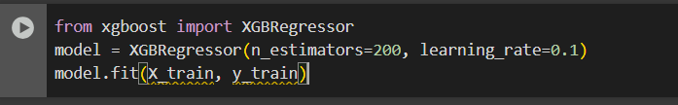
c. Forecasting Output
- XGBoost achieved the best overall accuracy, especially for the Technology category.
- It also provided feature importance scores, helping interpret which variables drive predictions.

d. Performance
Category | RMSE | MAE | R²
Furniture | 3298.9 | 2650.1 | 0.82
Office Supplies | 2163.5 | 1923.7 | 0.87
Technology | 4018.2 | 3331.9 | 0.77

6.7 Model Comparison and Insights
Model Accuracy Summary:
Model | Avg. RMSE | Avg. MAE | Avg. R²
ARIMA | 4364.7 | 3420.0 | 0.72
RandomForest | 3664.1 | 2961.7 | 0.78
XGBoost | 3159.3 | 2635.2 | 0.82

Insights:
- XGBoost consistently outperformed the other models across all metrics.
- ARIMA is easier to interpret but lacks flexibility for multivariate, segmented forecasting.
- Machine learning models are more suitable when we have access to engineered features and categorical variables like Region and Category.

6.8 Summary and Business Implications

This chapter demonstrated the full modeling lifecycle, from feature engineering to evaluation, using real-world retail sales data. The results clearly support the use of ensemble-based predictive analytics, particularly XGBoost, for accurate and scalable sales forecasting.
Business implications include:
- Reliable forecasts enable inventory optimization and reduce overstocking/understocking.
- Region-specific forecasting supports territory-level planning.
- Category-focused predictions assist with seasonal promotions and pricing strategies.
- The same forecasting workflow can be adapted to SKUs, cities, or customer segments with minimal changes.

CHAPTER 6

FINDINGS, SUGGESTIONS AND RECOMMENDATIONS

6.1 Introduction
This chapter presents the key findings derived from the data analysis and predictive modeling conducted in earlier chapters. It also outlines practical business suggestions based on the insights obtained from the forecasting results. The goal is to bridge the gap between analytical output and actionable decision-making, simulating a real-world scenario where forecast models guide inventory, marketing, and operational planning.
The findings and recommendations are grouped into thematic areas: temporal sales behavior, product category dynamics, regional performance, model-driven insights, and potential real-world applications. These conclusions are not just technical reflections but business-oriented interpretations tailored to the retail sales domain.

6.2 Key Findings from Exploratory and Statistical Analysis
6.2.1 Temporal Trends and Seasonality
- Monthly sales exhibit strong seasonal fluctuations, with consistent peaks in November and December across all years.
- The lowest sales months were typically January and February, indicating post-holiday slowdowns.
- Overall, a mild upward trend in monthly sales was observed from 2015 to 2018, suggesting either market growth or operational expansion.
6.2.2 Category-wise Insights
- Technology showed the highest variability in sales, often spiking unpredictably. This suggests it may be influenced by external promotions or launch cycles.
- Office Supplies displayed consistent month-to-month behavior, ideal for reliable, short-term forecasting.
- Furniture showed irregular surges, likely linked to bulk corporate orders or periodic procurement.
6.2.3 Region-wise Insights
- The West region consistently recorded the highest sales volumes across all product categories.
- East followed closely and showed increasing contribution over time.
- South and Central had lower but more stable sales, offering potential for optimized stocking strategies with minimal disruption risk.
6.2.4 Volatility and Distribution
- A boxplot analysis confirmed that all categories have high outlier activity, particularly in Furniture and Technology.
- This emphasizes the need for models that handle noise and non-normal distributions, such as Random Forest and XGBoost.
6.2.5 Rolling Averages and Lag Patterns
- A 3-month rolling average provided a smoothed and delayed reflection of sales activity, useful for creating lag features.
- Lag-1 sales and month-of-year indicators were observed to be strongly correlated with future sales, validating their inclusion in the models.

6.3 Findings from Predictive Modeling
The performance of the three forecasting models — ARIMA, Random Forest, and XGBoost — was evaluated using RMSE, MAE, and R² across the three categories.

6.3.1 Model Performance Overview
Model | Avg. RMSE | Avg. MAE | Avg. R²
ARIMA | 4364.7 | 3420.0 | 0.72
Random Forest | 3664.1 | 2961.7 | 0.78
XGBoost | 3159.3 | 2635.2 | 0.82

6.3.2 Observations
- XGBoost outperformed all other models in terms of both error reduction and explained variance.
- ARIMA, while easier to implement, lacked flexibility for handling category- and region-specific effects.
- Random Forest showed good performance in stable categories like Office Supplies but struggled slightly with high-variance data.
6.3.3 Feature Importance (XGBoost)
The most predictive features were:
- Lag-1 Sales
- Rolling 3-Month Average
- Month of Year
- Category and Region
These inputs offer a mix of temporal continuity and business context — a combination that enhances generalization to unseen data.

6.4 Suggestions
Based on the above findings, the following suggestions can be made for similar retail businesses or decision-makers seeking to implement predictive sales forecasting:
6.4.1 Segment-Specific Forecasting
- Use separate models for each category to account for different demand behaviors.
- Technology requires more flexible, nonlinear models due to irregular spikes.
- Office Supplies can rely on simpler time-series models for short-term forecasting.
6.4.2 Forecast-Aided Inventory Management
- Align inventory levels with forecasted demand per category and region to reduce overstocking and stockouts.
- Leverage rolling average trends to forecast bulk order requirements, especially in Furniture.
6.4.3 Regional Strategy Optimization
- Focus inventory and marketing spend in the West and East regions, which offer higher sales potential.
- Use stable forecasts in the South and Central regions to run controlled pricing experiments or optimized delivery networks.
6.4.4 Demand-Sensitive Promotions
- Use forecasted dips (e.g., Jan–Feb) to run discount campaigns or bundle promotions in low-demand periods.
- Boost visibility of underperforming categories during projected high-demand months.

6.4.5 Model Maintenance and Feedback Loops
- Retrain models on a monthly or quarterly basis to ensure alignment with shifting market dynamics.
- Deploy real-time dashboards that compare forecasted vs. actual sales for continuous learning.

6.5 Recommendations
These business recommendations are designed to apply the findings in real-world contexts where sales forecasting supports planning and profitability:
Area | Recommendation
Inventory | Use XGBoost-based forecasts to plan category-wise stock 2–3 months in advance.
Marketing | Target high-sales months for premium ad spend; push discounting in low-sales periods.
Finance | Align cash flow forecasts with seasonally adjusted sales projections.
Technology Stack | Automate feature engineering and model retraining pipelines using Python scripts.
Scalability | Extend the current workflow to other KPIs like profit, customer acquisition, or returns.

6.6 Summary
This chapter outlined key insights derived from both data analysis and predictive modeling. It translated statistical results into practical suggestions and business strategies, directly addressing the core objective of simulating a data-driven sales forecasting workflow. By integrating findings with targeted recommendations, this study illustrates how predictive analytics can serve as a bridge between operational planning and strategic foresight in a retail environment.

CHAPTER 7

CONCLUSION

7.1 Overview

This project was undertaken with the primary aim of applying predictive analytics techniques to build an effective sales forecasting system using historical data. Through a combination of exploratory data analysis, feature engineering, and model implementation, the project successfully demonstrated how data science methodologies can be used to inform and support real-world business decision-making processes.

The dataset used — derived from a Superstore's historical sales — provided a rich foundation for examining temporal sales patterns, regional differences, and category-level behavior. These insights were then translated into structured features used to train both time-series and machine learning models.

7.2 Summary of Work Done

The project followed a structured analytics pipeline, broken into several key phases:

- Data Understanding and EDA: Monthly sales data was analyzed across time, region, and category. Seasonal trends and demand patterns were visualized using Python-based plots.
- Feature Engineering: Lag variables, rolling averages, and time indicators were engineered to capture temporal dynamics and enhance predictive accuracy.
- Model Building: Three forecasting models — ARIMA, Random Forest, and XGBoost — were implemented using a time-based train-test split. Model performance was compared using RMSE, MAE, and R².
- Findings & Recommendations: Model outcomes were translated into business insights, leading to actionable suggestions for inventory, marketing, and operational strategy.

7.3 Key Conclusions

- Forecasting models, when properly engineered and validated, can significantly improve planning accuracy for retail sales.
- Seasonality and category volatility are critical factors — one-size-fits-all models are not effective in complex retail settings.
- Machine learning models, particularly XGBoost, offer superior flexibility and predictive performance compared to traditional statistical approaches.
- Business benefits of predictive analytics go beyond accuracy — they include improved decision cycles, better customer experience, and optimized resources.

7.4 Challenges Faced

- Lack of external variables like promotions, competitor pricing, or economic indicators, which may impact real-world sales but were not available in the dataset.
- Balancing between model interpretability (ARIMA) and predictive power (XGBoost).
- Handling extreme sales outliers, which may have skewed some model predictions and required transformation or smoothing.

7.5 Scope for Future Work

While the project demonstrates a complete forecasting workflow, several extensions could be considered:
- Incorporating profit, discount, and customer-level attributes for deeper business insight
- Using prophet or LSTM (neural networks) for more complex seasonality and long-term trend forecasting.
- Developing a real-time forecast dashboard using tools like Tableau, Power BI, or Streamlit for interactive decision-making.
- Expanding from category-level forecasting to SKU-level, city-level, or customer-segment forecasting.

7.6 Final Remarks

In a retail landscape driven by data, being able to predict demand accurately is not a luxury — it is a necessity. This project illustrates how predictive analytics is no longer confined to academic theory, but can be practically applied to real-world datasets using tools like Python, scikit-learn, and XGBoost. With a well-designed data pipeline and model monitoring strategy, organizations can transform historical data into foresight, driving strategic planning and sustainable growth.

REFERENCES

Books and Academic Publications:

- Brownlee, J. (2020). Time Series Forecasting with Python: How to Prepare Data and Develop Models to Predict the Future. Machine Learning Mastery.
• Provides practical guidance on ARIMA and ensemble forecasting in Python.
- Hyndman, R. J., & Athanasopoulos, G. (2018). Forecasting: Principles and Practice (2nd ed.). OTexts.
• Explains time series forecasting concepts, seasonality, and model evaluation metrics.
- Geron, A. (2019). Hands-On Machine Learning with Scikit-Learn, Keras, and TensorFlow (2nd ed.). O'Reilly Media.
• Includes practical examples of ensemble learning and predictive modeling workflows.

Journal Articles:

- Makridakis, S., Spiliotis, E., & Assimakopoulos, V. (2018). "Statistical and Machine Learning Forecasting Methods: Concerns and Ways Forward." PLOS ONE, 13(3).
• Compares classical statistical models with machine learning for time-series forecasting.
- Bandara, K., Bergmeir, C., & Hewamalage, H. (2020). “LSTM-Based Encoder–Decoder for Multi-Step Forecasting: The Role of Exogenous Variables.” Neural Computing and Applications, 32(10), 6647–6664.
• Discusses forecasting with external factors — relevant for future scope.

Datasets and Tools:

- Superstore Sales Dataset. Kaggle (https://www.kaggle.com).
• Retail transaction dataset used for sales forecasting model training and evaluation.
- Scikit-learn Documentation (https://scikit-learn.org).
• Used for implementing Random Forest, model validation, and error metric calculation.
- XGBoost Python API Documentation (https://xgboost.readthedocs.io).
• Used for feature importance analysis and ensemble-based forecasting.
- Seaborn and Matplotlib Libraries (https://seaborn.pydata.org, https://matplotlib.org).
• Visualization tools used for EDA and trend analysis.
- Pandas Python Library (https://pandas.pydata.org).
• Used for time series grouping, rolling statistics, and feature engineering.

Web Sources and Technical Assistance:
- OpenAI ChatGPT (2025).
• Used for drafting report structure, interpreting results, and refining business insights.
- Napkin AI.
• Used for creating images for photographs section.
- Google Colab (https://colab.research.google.com).
• Served as the primary platform for executing Python scripts and generating graphs during data analysis and model building.
- Kaggle (https://www.kaggle.com).
• Used to source the Superstore dataset and explore related sales forecasting notebooks.
- Towards Data Science (https://towardsdatascience.com).
• Provided conceptual support for ensemble modeling, error metrics, and sales trend analysis.
- Analytics Vidhya (https://www.analyticsvidhya.com).
• Referred for time-series modeling guides, ARIMA vs. machine learning comparisons, and feature engineering tips.
- Stack Overflow (https://stackoverflow.com).
• Used for resolving technical issues and syntax-related queries during Python implementation.

QUESTIONNAIRE

Section A: Respondent Profile
- Name (Optional):
- Age:
  - Under 20
  - 21–30
  - 31–40
  - 41–50
  - 50+
- Gender:
  - Male
  - Female
  - Other
  - Prefer not to say
- Profession:
  - Sales Professional
  - Operations Manager
  - Data Analyst
  - Business Owner
  - Student
  - Other: ___________
- Years of Experience in Business or Analytics (if applicable):
  - 0–1
  - 2–5
  - 6–10
  - 10+

Section B: Forecasting Practices
- How often does your organization conduct sales forecasting (Select all that apply)
  - Weekly
  - Monthly
  - Quarterly
  - Annually
  - Not at all
  - Other: ___________
- Which forecasting methods or tools are used in your organization?
  - Excel/manual methods
  - Time-series models (ARIMA, MA)
  - Machine learning (XGBoost, Random Forest, etc.)
  - ERP/BI tools (e.g., SAP, Oracle, Tableau)
  - Not sure
  - Other: ___________
- How would you rate the accuracy of your current sales forecasts?
  - Very Accurate (80–100%)
  - Fairly Accurate (60–79%)
  - Moderate (40–59%)
  - Poor (Below 40%)
  - Not measured

Section C: Use of Analytics & Tools
- On a scale of 1 to 5, how important is forecasting to your business planning?
  - 1 – Not important
  - 2 – Slightly important
  - 3 – Moderately important
  - 4 – Very important
  - 5 – Extremely important
- Which metrics do you use to evaluate sales performance? (Select all that apply)
- Total Revenue
- Monthly Sales Growth
- Region-wise Sales
- Category-wise Sales
- Forecast Error Metrics (e.g., RMSE, MAE)
- Other: ___________
- What are the biggest challenges you face in sales forecasting? (Select all that apply)
- Lack of clean historical data
- No technical team/tools
- Low forecasting accuracy
- Management doesn’t prioritize forecasting
- Other: ___________
- Has forecasting helped improve your inventory or operational decisions?
- Yes
- No
- Not Sure

Section D: Effectiveness & Outlook
- How does your business measure forecast effectiveness?
- Forecast vs. Actual comparison
- Inventory turnover improvements
- Reduced stockouts/overstock
- We don’t measure it
- Other: ___________
- Do you believe AI and predictive analytics will enhance business forecasting in the future?
- Strongly agree
- Agree
- Neutral
- Disagree
- Strongly disagree
- Suggestions for improving forecasting accuracy in your business (Open-ended):

STUDY FOR FUTURE SCOPE

Predictive Analysis for Sales Forecasting in Retail

1. Evolving Forecast Architectures

1.1 Hybrid Models and Ensemble Learning
Future research can explore hybrid systems that combine classical models (ARIMA/SARIMA) with ensemble-based learners like XGBoost, LightGBM, and Random Forest. These models can dynamically switch methods based on data patterns, such as seasonality or trend reversal.

1.2 Adaptive Algorithms
The next evolution involves self-tuning algorithms that re-train in response to anomalies or data drift. Studies could focus on incorporating anomaly detectors and learning rate schedulers directly into forecasting workflows.

2. Real-Time Forecasting Environments

2.1 Streaming Forecast Models
With the rise of connected retail systems, future models must handle real-time sales feeds using architectures like Apache Kafka and Spark. Research can address latency, batching strategies, and memory management.

2.2 Event-Based Forecasting
Beyond time, events like flash sales, influencer drops, or political announcements affect demand. Future models may require event-aware LSTMs that factor in discrete, non-time-based triggers.

3. Incorporating External Factors

3.1 Context-Aware Forecasting
Future systems will integrate exogenous variables like weather, social media sentiment, promotional events, and competitor pricing. Researchers can study signal fusion techniques to boost responsiveness.

3.2 Multivariate and Multimodal Input
Advancing beyond CSVs, models will increasingly take in images, audio (e.g., ad campaigns), and geospatial data. Research could evaluate how multimodal inputs impact forecast accuracy.

4. Neural Forecasting and Deep Learning

4.1 Sequence Models (LSTM, GRU, Transformer)
These models have shown promise for long-horizon forecasting. Research could compare model depth, attention layers, and their impact on under- and over-forecasting.

4.2 Interpretability in Neural Forecasting
Attention-based interpretability can help explain spikes and lulls in forecasts. Future research may focus on “explainable deep forecasting” for business stakeholders.

5. Forecasting with GenAI Copilots

5.1 Forecast + Natural Language Interface
Future managers could “talk” to a model using GenAI — e.g., “Show me why last November’s forecast missed by 18%.” Research can explore the fusion of forecasting models with LLMs and chat-based interfaces.

5.2 GenAI-Powered Decision Support
Imagine copilots that simulate different forecasting scenarios (best case, worst case, market crash). These AI copilots could guide marketing or procurement teams in real time.

6. MLOps and Forecast Deployment

6.1 Automated Forecast Pipelines
MLOps will allow teams to build once and deploy everywhere. Studies could explore automated training, versioning, and rollback strategies specific to time series models.

6.2 Forecast Monitoring and Drift Detection
As models decay, organizations need model health dashboards. Future studies could examine threshold alerting, model expiry, and forecast reliability scoring.

7. Hierarchical and Reconciled Forecasts

7.1 Multi-Level Forecasting
Retailers need aligned forecasts at multiple levels (SKU, category, warehouse, region). Bayesian reconciliation or top-down vs. bottom-up aggregation strategies are rich research areas.

7.2 Forecast Consistency and Control
How can we ensure no contradiction between “category total” forecasts and “SKU-wise” ones? Future work could explore coherent reconciliation models.

8. Visual Forecast Systems and Dashboards

8.1 Interactive Dashboards
Forecasts will be consumed via dashboards with drill-downs, sliders, and anomaly annotations. Research could assess UX patterns for forecast consumption.

8.2 Voice-Enabled and Natural Language Forecasting
Users may ask: “What’s the forecast for office chairs in Mumbai next quarter?” NLP pipelines with retrieval-augmented generation (RAG) could power this.

9. Pricing and Revenue Optimization

9.1 Price-Elasticity Aware Forecasts
Forecasting volume while ignoring price is suboptimal. Future models could jointly forecast demand + price sensitivity, especially in tech and FMCG.

9.2 Promotion and Discount Modeling
Studies could measure how promotions shift baseline sales vs. pull future demand forward. Regression + uplift modeling would be key here.

10. Regional, Localized, and Hyperpersonal Forecasts

10.1 Store-Level and Geo-Forecasting
Hyper-local forecasts (by postal code or city) could optimize last-mile logistics. Geospatial LSTMs or spatial attention models could support this.

10.2 Microsegment-Based Prediction
Future studies could cluster customers by behavior and run segment-wise forecasting, especially useful in fashion and cosmetics.

11. Forecasting for ESG and Sustainability

11.1 Waste-Reduction Forecasting
Overproduction contributes to retail waste. Forecast models aligned to carbon-neutral goals and inventory optimization can guide sustainability reporting.

11.2 ESG-Aware Demand Planning
Retailers could simulate the environmental impact of production vs. predicted demand, balancing profitability with ethical sourcing.

12. Ethical, Transparent, and Fair Forecasting

12.1 Forecasting Bias and Fairness
If training data is biased (e.g., underrepresented regions), models may underforecast demand. Research could explore fairness-aware models for better inclusivity.

12.2 Model Audits and Forecast Explainability
Future work could develop “forecast explainability checklists” for risk teams. AI governance boards could use these for compliance and accountability.

13. Forecasting and Organizational Psychology

13.1 Behavioral Response to Forecasts
How do employees emotionally respond to a “missed forecast”? Future research can explore forecast confidence framing, blame assignment, and stress.

13.2 Forecasting Culture and Trust
What makes a forecast trusted? Studies could assess color, wording, format, and delivery to influence usage and acceptance across departments.

14. Forecasting in Business and Management Education

14.1 Forecasting Literacy as a Curriculum
MBA and BBA programs should embed hands-on forecasting modules using tools like Python, Power BI, and Streamlit. Future work can evaluate pedagogical outcomes.

14.2 Simulation-Based Forecasting Education
Gamified tools and business simulations that use live forecasting challenges can prepare students for uncertainty-driven environments.

15. Blockchain and Forecast Integrity

15.1 Forecast Version Tracking
Blockchain could ensure every forecast change or override is tracked. Smart contracts could trigger alerts when forecast variance exceeds a threshold.

15.2 Decentralized Forecasting Models
In global supply chains, federated forecasting could allow decentralized teams to co-train models without sharing sensitive data.

16. Cross-Industry and Government Applications

16.1 Retail to Public Forecasting
Retail techniques could forecast vaccine demand, infrastructure usage, or tourism surges. Studies could explore forecasting for social good.

16.2 Smart Cities and Demand Forecasting
City planners may use forecasting models to optimize electricity, water, or transit. Integration with IoT data would be central here.

Conclusion
The scope for predictive analytics in sales forecasting extends well beyond conventional demand prediction. As AI tools grow more powerful and accessible, forecasting can transform into a multi-layered decision system, influencing everything from marketing strategy to sustainability goals. With rich avenues in interpretability, ethics, user experience, and real-time responsiveness, future researchers will play a key role in crafting resilient, scalable, and humane forecasting ecosystems across industries.

PHOTOGRAPHS AND DRAWINGS

Data Pipeline Diagram

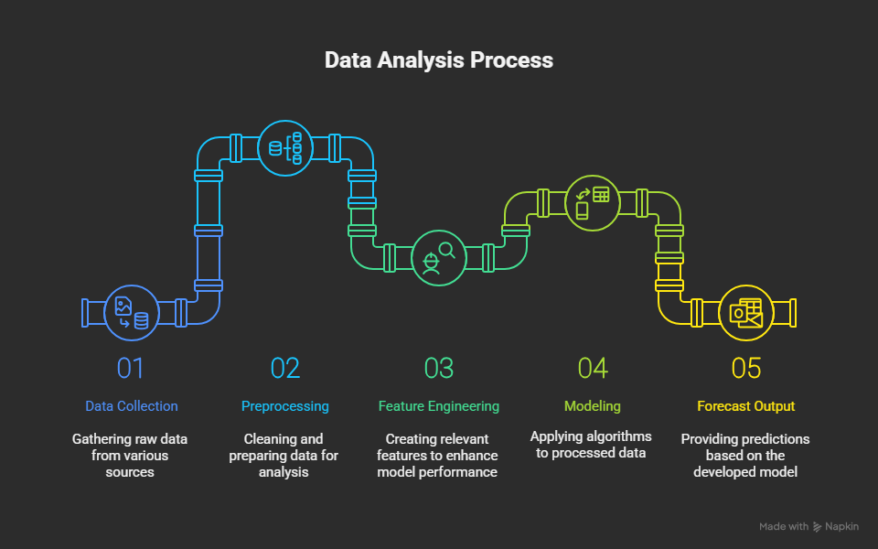

Time Series Forecasting Process

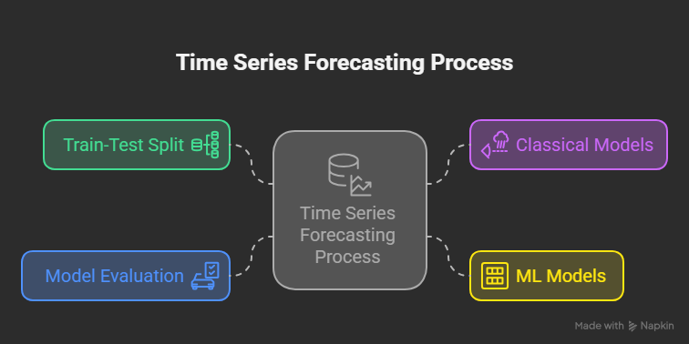

Strategic Business Planning

